**Nume**: Panican

**Prenume**: Catalin

**E-mail**: panicancatalin40@gmail.com

**Poza**:

**Asteptari legate de educatie**:

* Aprofundarea de cunostinte in legatura cu electronica si ingineria
* Aflarea de lucruri noi

**Discipline**: <https://etti.utcluj.ro/planuri-de-invatamant.html>

|  |  |  |
| --- | --- | --- |
| Disciplina | An | Link |
| Informatica Aplicata | 1 | https://etti.utcluj.ro/files/Acasa/Site/FiseDisciplina/EaRo/06.pdf |
| Circuite integrate digitale | 2 | https://etti.utcluj.ro/files/Acasa/Site/FiseDisciplina/EaRo/19.pdf |
| Componente si circuite pasive | 1 | https://etti.utcluj.ro/files/Acasa/Site/FiseDisciplina/EaRo/05a.pdf |
| Electronica de putere | 3 | https://etti.utcluj.ro/files/Acasa/Site/FiseDisciplina/EaRo/36.pdf |
| Sisteme fuzzy | 4 | https://etti.utcluj.ro/files/Acasa/Site/FiseDisciplina/EaRo/36.pdf |

**Hobby-uri**:

* Citit
* Gaming
* Calculatoare

1. a. head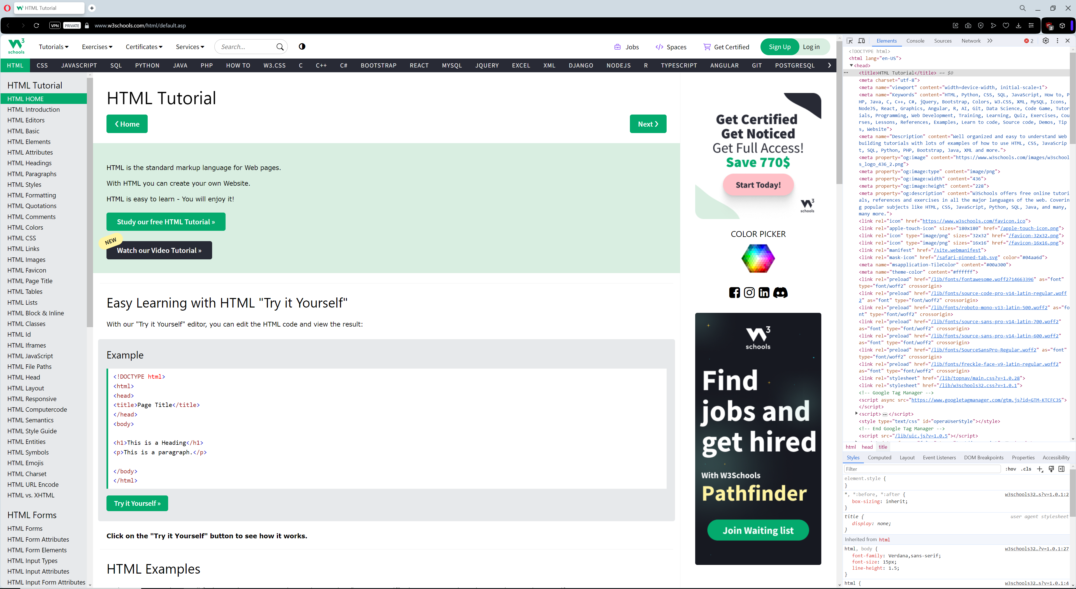

body 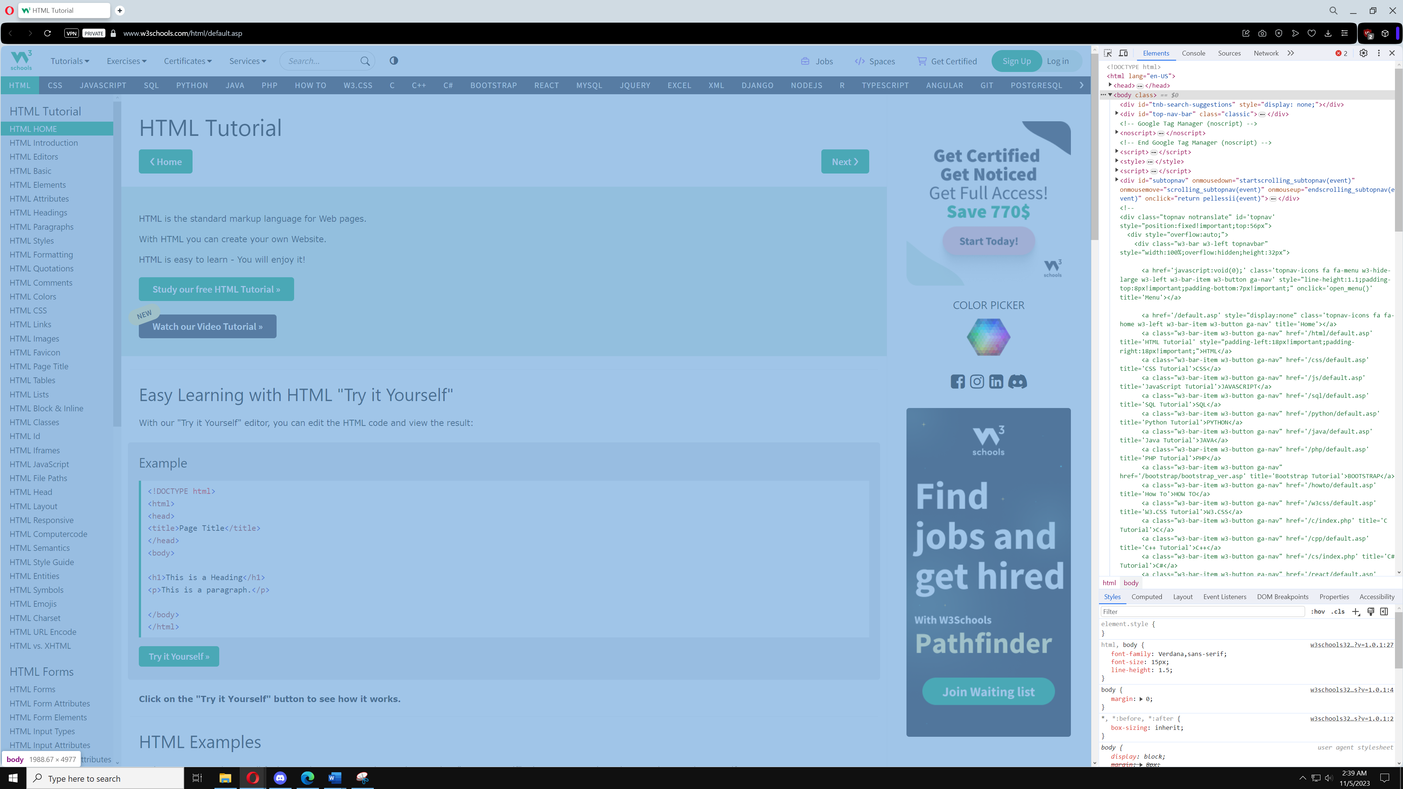

b. elemente folosite pentru:

paragrafe- 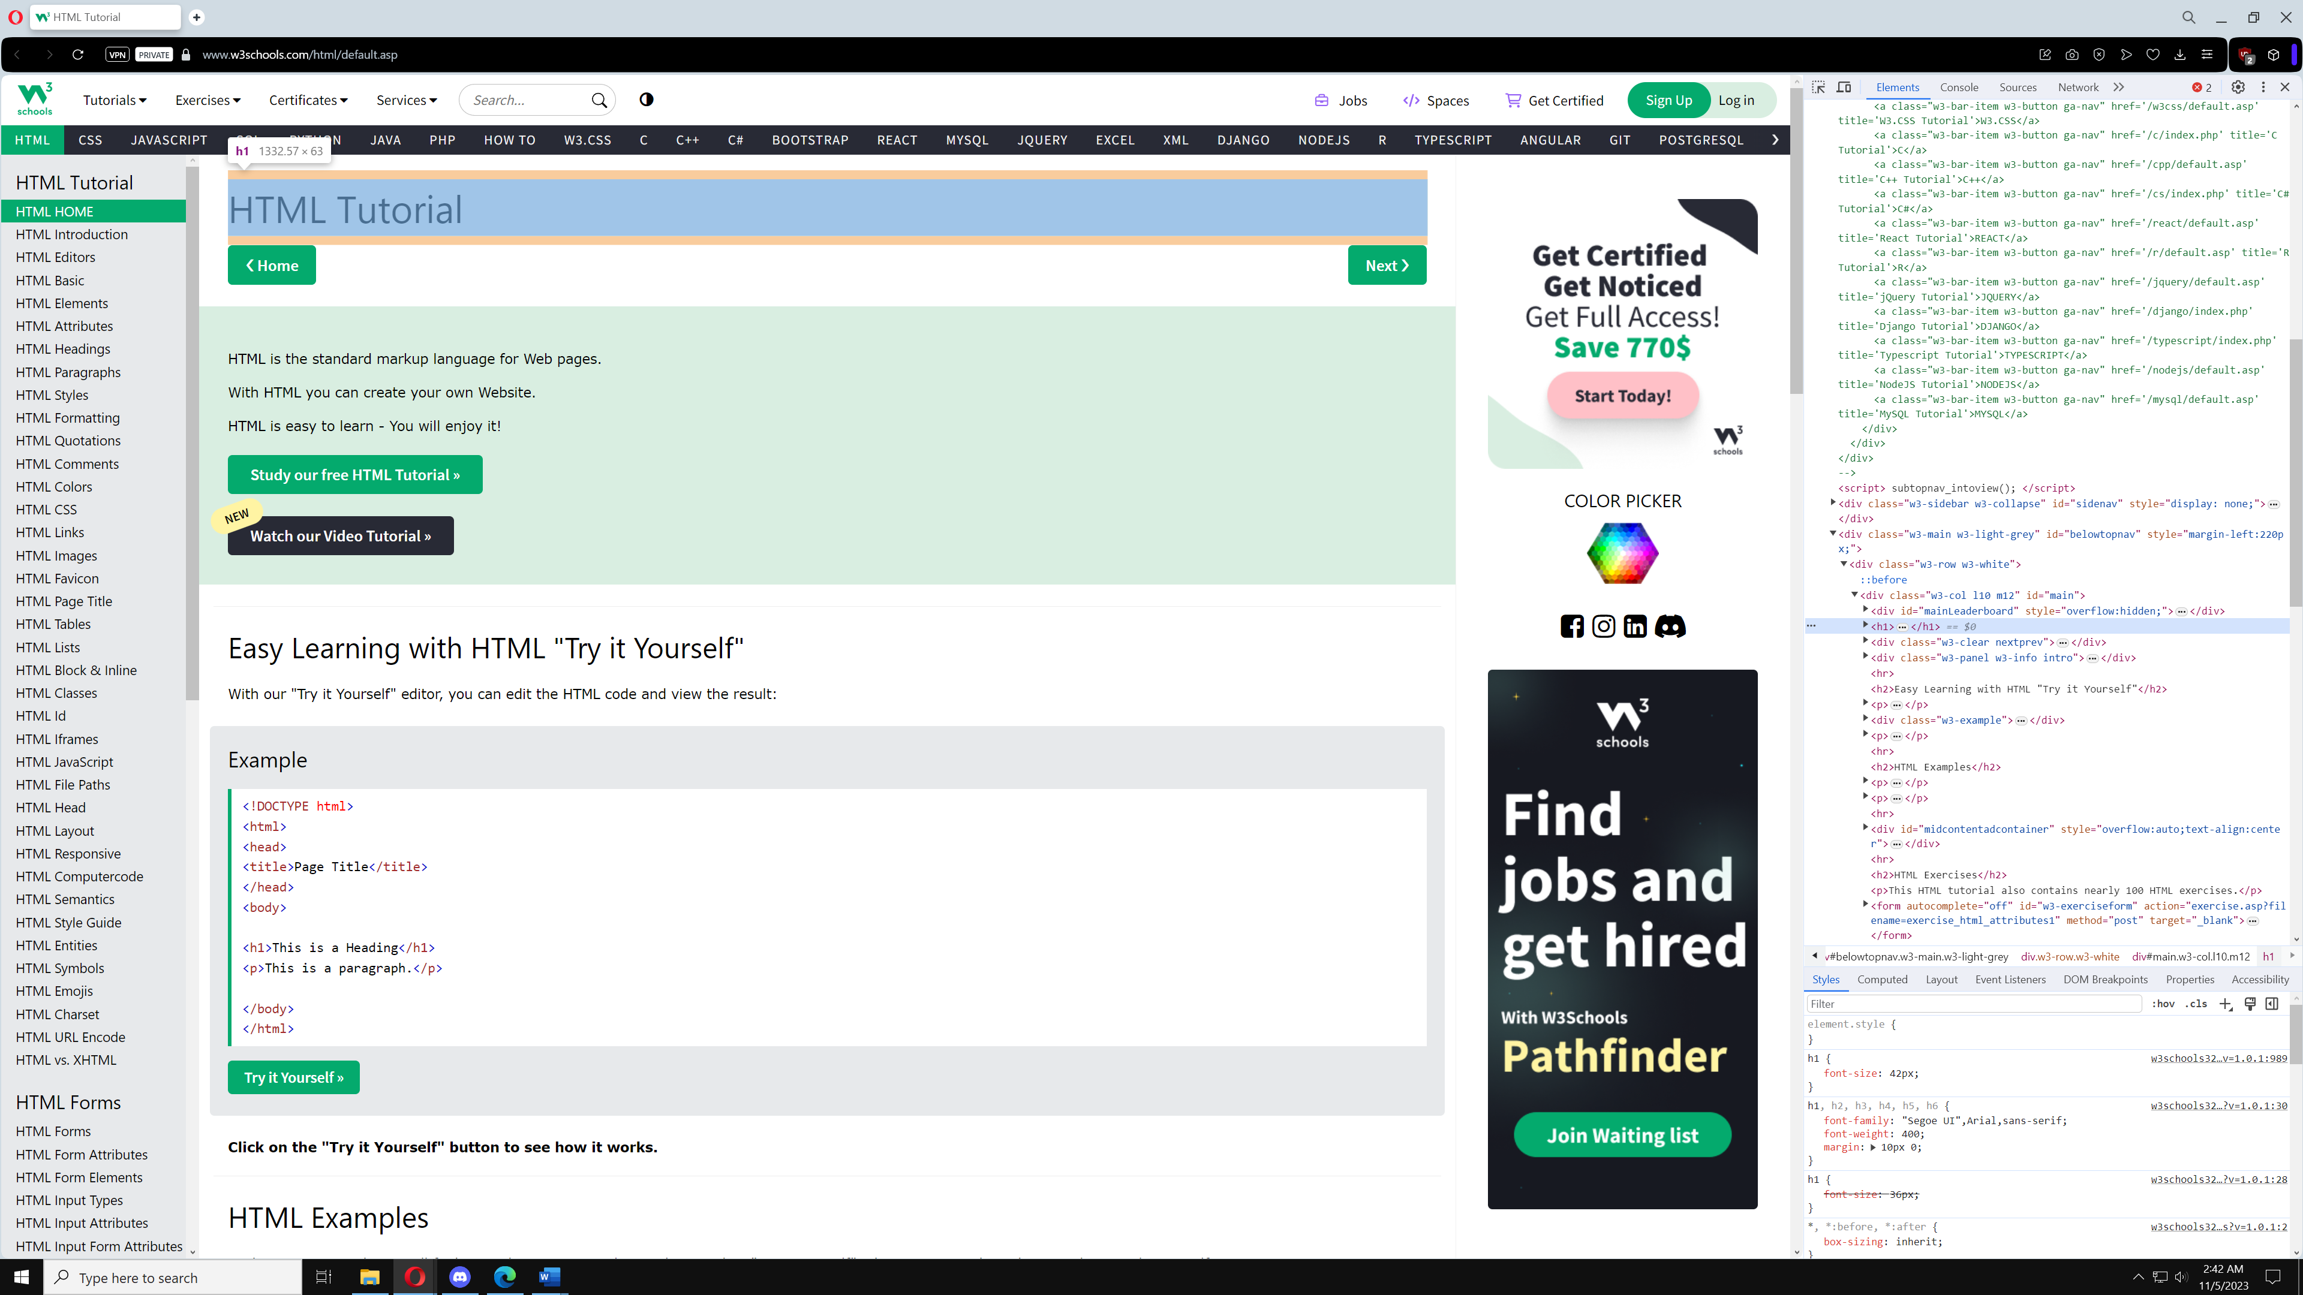

link-uri: 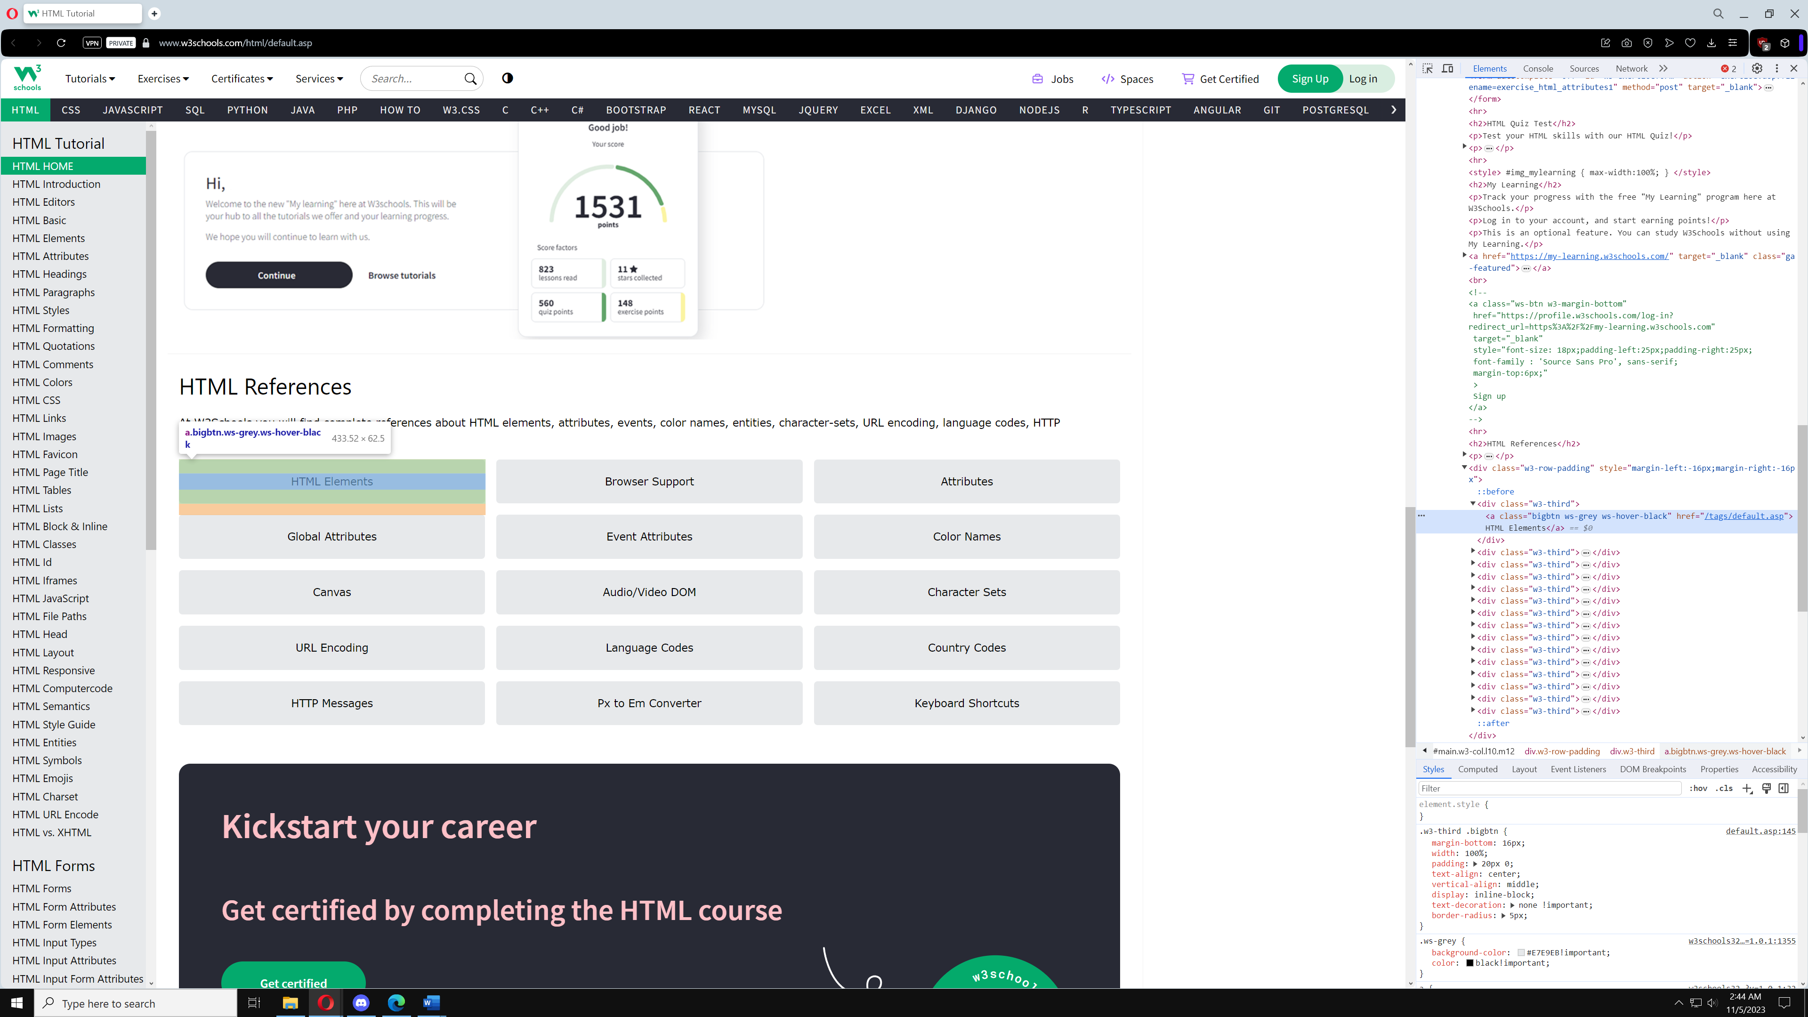

cautare: 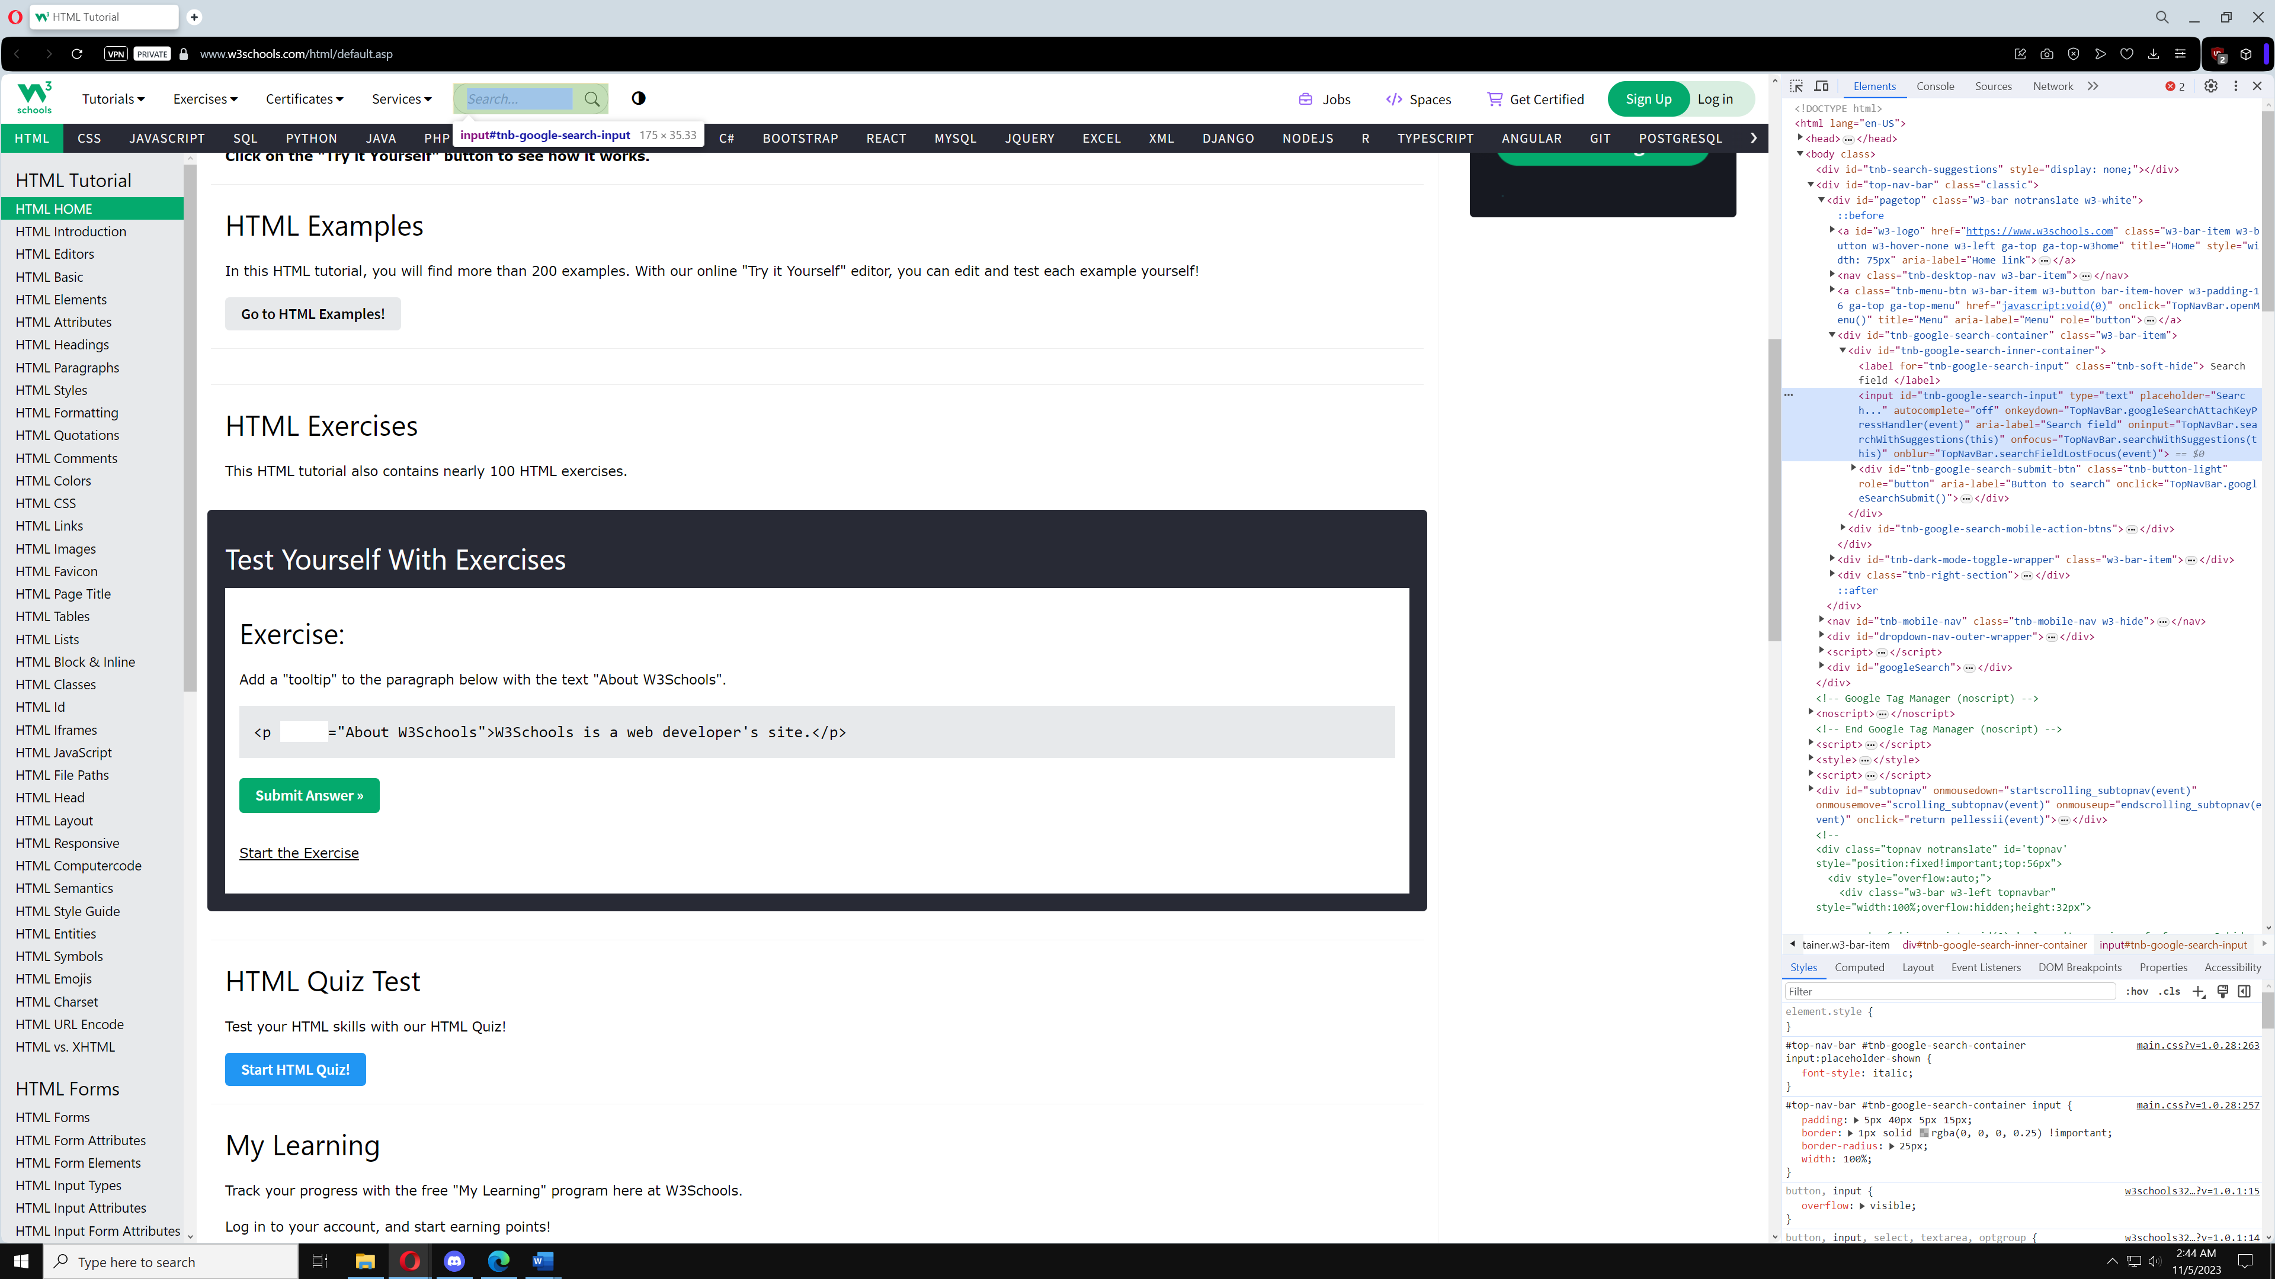

c. modificare contrinut: 